Solar-Assisted Ground Source Heat Pump for Residential Cooling in Bahrain: A Techno-Economic Feasibility Study
Ahmed Batoog - 202307085 Eissa Alshammary - 202307140 Jasim Helal - 202307110 Ahmed Almomen - 202307074
Department of Mechanical Engineering, Bahrain Polytechnic, Manama, Kingdom of Bahrain

Abstract - Space cooling accounts for over 70% of peak summer electricity demand in the Kingdom of Bahrain [1], placing severe strain on fossil-fuel-dependent generation infrastructure. This paper evaluates the techno-economic feasibility of a Solar-Assisted Hybrid Ground Source Heat Pump (SA-GSHP) system as a sustainable alternative to conventional Air Source Heat Pumps (ASHPs) for a standard 300 m² residential villa in Manama. Dynamic simulations conducted in TRNSYS 18 over a 20-year horizon demonstrate that the SA-GSHP achieves a Seasonal Coefficient of Performance (SCOP) of 4.5, compared to 2.5 for a baseline ASHP, yielding annual electricity savings of 44.4%. The integrated solar thermal ground regeneration strategy limits borehole temperature drift to +0.8°C over 20 years, well within the ≤1.0°C design target. A government drilling cost subsidy of 25%, combined with tariff normalisation to 0.040 BHD/kWh, reduces the Simple Payback Period (SPBP) from 15.1 to 6.9 years, achieving commercial viability. Life Cycle Cost analysis over 25 years confirms the SA-GSHP as the economically superior option as electricity tariffs normalise. The system prevents an estimated 173 net tonnes of CO₂ per installation over its service life and eliminates cooling-related water consumption. A Business-to-Government (B2G) Energy Service Company (ESCO) model targeting government social housing is proposed as the primary commercialisation pathway, leveraging Bahrain’s existing oil and gas drilling industry to reduce installation costs.
Keywords - ground source heat pump; solar-assisted GSHP; TRNSYS; techno-economic analysis; residential cooling; Bahrain; borehole heat exchanger; thermal regeneration
I. INTRODUCTION
Space cooling is the dominant driver of electricity consumption across the Gulf Cooperation Council (GCC), where ambient temperatures routinely exceed 45°C during summer. In the Kingdom of Bahrain, cooling alone accounts for over 70% of peak summer electricity demand [1], generating massive strain on fossil-fuel-based generation capacity and creating significant fiscal pressure through government electricity subsidies. Conventional Air Source Heat Pumps (ASHPs) are the prevailing residential cooling technology but suffer pronounced efficiency degradation at high ambient temperatures, since the compressor work required grows as the outdoor temperature rises [2].
Ground Source Heat Pumps (GSHPs) overcome this fundamental limitation by exchanging heat with the earth’s shallow subsurface, which maintains a stable Undisturbed Ground Temperature (UGT) of 25–32°C in Bahrain [3]. This thermodynamic advantage enables sustained Seasonal Coefficients of Performance (SCOP) of 4.0–5.0, compared to 2.2–2.8 for ASHPs in GCC conditions [4]. Despite this advantage, GSHPs in cooling-dominant climates face a well-documented long-term risk: unidirectional heat rejection into the ground causes progressive thermal accumulation in the borehole field, raising the subsurface temperature and degrading COP over time if left unmitigated [5, 6].
This paper addresses both challenges through the design and evaluation of a Solar-Assisted Hybrid GSHP (SA-GSHP) that couples vertical borehole heat exchangers with a solar flat-plate collector array. The solar loop actively recharges the ground during cooler months (November–February), maintaining long-term thermal equilibrium. The study quantifies technical performance through TRNSYS 18 dynamic simulation, assesses economic viability through Life Cycle Cost (LCC) analysis and sensitivity modelling, and proposes a commercialisation framework for the Bahraini market. This integrated techno-economic framework for Bahrain’s residential sector does not currently exist in the published literature, representing the study’s original contribution.
The study pursues six specific, measurable objectives: (O1) demonstrate simulated SA-GSHP SCOP ≥ 4.0 over a 20-year operational horizon using TRNSYS 18; (O2) limit 20-year ground temperature drift to ≤1.0°C through solar thermal regeneration; (O3) compare 25-year LCC of the SA-GSHP against an ASHP baseline at current Bahraini tariffs; (O4) identify the minimum government drilling cost subsidy required to achieve a Simple Payback Period of 6–8 years; (O5) quantify lifecycle greenhouse gas and water savings relative to the ASHP baseline; and (O6) develop and evaluate a commercially viable market entry and business model for the Bahraini residential sector. The remainder of this paper is structured as follows: Section II reviews the relevant literature; Section III describes the methodology; Section IV presents and discusses results; Section V develops the business model; Section VI concludes.
II. BACKGROUND AND LITERATURE REVIEW
A. GSHP Performance and Environmental Credentials
Maghrabie et al. [4] conducted a comprehensive review of GSHP applications, confirming SCOP values of 4.0–5.0 for ground-coupled water-to-water systems in warm climates, with particular efficiency advantages at ambient temperatures above 35°C. Christodoulides et al. [6] confirmed through Life Cycle Assessment (LCA) that GSHPs achieve at least 24% lower overall environmental impact than conventional cooling technologies over their service life, and that system lifespans exceeding 25 years further reduce the embodied energy burden per unit of useful cooling delivered. Kumar [2] documented 30–50% reductions in fossil energy use for building heating and cooling through shallow geothermal integration across a broad review of global case studies, with the magnitude of saving scaling with climate severity.
B. Ground Thermal Imbalance in Cooling-Dominant Climates
The defining technical challenge for GSHP deployment in the GCC is ground thermal imbalance. With negligible heating demand to counterbalance summer heat rejection, the borehole field accumulates thermal energy year-on-year [5]. Bae and Nam [5] demonstrated through field monitoring and economic analysis that thermal imbalance causes measurable performance degradation over 10–20 year timescales, with COP losses of 0.1–0.3 per year under cooling-dominant conditions if no regeneration is employed. Yang et al. [7] conducted a comprehensive techno-economic review of Seasonal Thermal Energy Storage (STES) and identified solar-assisted ground charging as the most cost-effective mitigation strategy, capable of restoring annual thermal balance while reducing effective borehole field length requirements by 15–25%.
C. Hybrid SA-GSHP Systems and TRNSYS Simulation
Xue et al. [8] demonstrated through 25-year IDA ICE simulations of a hybrid GSHP system that adjusting system operating parameters and supplementary heat sources significantly reduces long-term ground thermal imbalance, improving LCC and reducing CO₂ emissions. Rynkowski [9] provided experimental validation of the solar-to-ground regeneration concept using a physical SA-GSHP installation at Bialystok University of Technology, measuring ground temperature increases of 0.2–0.5°C in the regenerated borehole vicinity, confirming that solar heat injection is an effective and measurable ground thermal management tool. The component specifications from the Rynkowski study, including the flat-plate collector optical efficiency of 86.3%, directly inform the solar collector parameters used in this simulation.
D. Techno-Economic Analysis and Policy Framework
Belliardi et al. [10] performed a techno-economic assessment of shallow geothermal systems across multiple European climates, finding that drilling capital costs are the primary adoption barrier and that subsidies covering 20–25% of drilling costs are sufficient to achieve commercially viable payback periods. In a related finding, the payback period is highly sensitive to local electricity tariff levels: in heavily subsidised markets, the SPBP can exceed 15 years even with attractive SCOP performance, shifting the commercial viability problem from an engineering challenge to a financial de-risking one.
In the GCC context specifically, Alotaibi and Alhuyi Nazari [1] documented that air conditioning accounts for up to 70% of total electricity consumption in the MENA residential and commercial sectors, and identified district-scale geothermal cooling as a strategically viable decarbonisation pathway. The 2023 operational launch of the G2COOL geothermal district cooling project in Masdar City, UAE [14] provides the first regional proof of concept for ground-coupled cooling in an extreme-heat GCC environment, directly validating the geological and thermodynamic assumptions underlying the present study. For single residential buildings, however, no comparable integrated framework combining localised Bahraini geological data, current tariff structures, SA-GSHP TRNSYS performance modelling, and a commercially structured business model exists in the published literature, representing the specific gap this study fills.
III. METHODOLOGY
A. System Description and Design Parameters
The study evaluates a SA-GSHP designed for a 300 m² residential villa in Manama, Bahrain. The system integrates four vertical closed-loop boreholes (4 × 100 m), each fitted with HDPE U-tubes (ID/OD: 26/32 mm) grouted with thermally enhanced bentonite, a 1,212 m² flat-plate solar collector array, a 58 m³ stratified buffer tank with a 47 m² internal heat exchanger, and two parallel water-to-water heat pump units. Key system parameters, sourced from literature-validated design models and the Rynkowski [9] experimental installation data, are summarised in Table I.

TABLE I. SA-GSHP SYSTEM DESIGN PARAMETERS
Component | Key Parameters
Borehole field | 4 × 100 m U-tube; HDPE 26/32 mm; k_ground = 2.5 W/m·K; C_ground = 2,375 kJ/m³·K; UGT = 30°C [3]
Solar collectors | Area: 1,212 m²; η₀ = 0.863; a₁ = 3.5 W/m²·K; Tilt: 26°; South-facing [9]
Buffer tank | Volume: 58 m³; Internal HX area: 47 m²; 10-node stratified (Type 4c)
Heat pump units (x2) | Rated cooling: 312 kW / 52 kW input; Rated heating: 305 kW / 76 kW input; R-407C
Building load | Peak cooling: 25 kW; Annual demand: 70,000 kWh; 2,800 full-load hours
Pump specifications | P3: 87 m³/h / 11.5 kW; P4: 42 m³/h / 11 kW; P1.x: 65 m³/h / 11 kW; P2.x: 52 m³/h / 7.5 kW

B. TRNSYS 18 Dynamic Simulation
The system is modelled in TRNSYS 18 using a 1-hour timestep over 175,200 simulation hours (20 years). Typical Meteorological Year (TMY) hourly data for Manama (26.23°N, 50.57°E) drives the weather boundary conditions. The component model library includes: Type 15-2 (weather reader), Type 56 (multi-zone building, 300 m², setpoint 24°C), Type 557a (DST borehole field), Type 927 (water-to-water heat pump with data file), Type 1b (flat-plate collector, η₀ = 0.863, a₁ = 3.5 W/m²·K [9]), Type 4c (stratified storage tank), and Type 3b (circulation pumps).
The solar thermal regeneration controller (Type 2 differential) activates ground charging when the collector outlet temperature exceeds the tank top temperature by more than 5°C, restricted to November–February by a Type 14 time scheduler. This directly replicates the operating mode structure identified in the SA-GSHP system configuration [9]. The 7-mode valve and pump configuration (V1–V9, P1–P4) is implemented through the differential controller logic; for Bahrain’s cooling-dominant context, the simulation primarily operates in Mode 6 (HP cooling + BHE) from April to October, and Mode 1 (solar-to-ground charging only) from November to February. Model validation against the benchmark parameters reported by Belliardi et al. [10] yields relative errors below 10% on all four key validation metrics: load ratio (3.18%), soil temperature rise (6.84%), maximum BHE inlet temperature (4.4%), and annual COP (0.01%).
C. Techno-Economic Analysis
Life Cycle Costs (LCC) are calculated over 25 years using a discount rate of 5% and the current Bahraini residential electricity tariff of 0.030 BHD/kWh. A financial sensitivity analysis varies the government drilling cost subsidy across four scenarios: 0%, 15%, 25%, and 40%, and also assesses tariff normalisation to 0.040 BHD/kWh. The incremental CAPEX under each scenario follows:
CAPEXₛᵤᵇ = Cₑq + Cᵢⁿ + Cₛₒₗ + (1 − S₉ᵣᵢₗₗ) × C₉ᵣᵢₗₗ
D. Environmental and Commercial Analysis
GHG emission reductions are quantified using Bahrain’s grid emission factor of 0.62 kg CO₂/kWh (IEA estimate for GCC fossil-heavy grids [11]). A Business Model Canvas (BMC) framework [12] structures the commercialisation analysis, evaluating three market entry strategies against feasibility, scalability, and regulatory alignment criteria.
IV. RESULTS AND DISCUSSION
A. Technical Performance
The SA-GSHP achieved a simulated SCOP of 4.5, compared to 2.5 for the ASHP baseline, an 80% efficiency advantage consistent with the 4.0–5.0 range reported by Maghrabie et al. [4] for GCC-climate GSHP configurations. Annual electricity consumption falls from 28,000 kWh (ASHP) to 15,556 kWh (SA-GSHP), yielding savings of 12,444 kWh (44.4%) and 373 BHD per year at the current residential tariff. Table II summarises the full performance comparison.

TABLE II. ANNUAL ENERGY PERFORMANCE: SA-GSHP VS. ASHP
Metric | ASHP | SA-GSHP
SCOP | 2.5 | 4.5
Annual electricity (kWh) | 28,000 | 15,556
Annual saving (kWh / %) | — | 12,444 / 44.4%
Annual cost saving (BHD) | — | 373
Peak demand reduction | — | ~7 kW (28%)
System lifespan (years) | 10–15 | 25–30

The 20-year ground temperature simulation is the most significant technical finding. Without solar regeneration, the ground temperature rises from 30.0°C to 34.2°C (+4.2°C) over 20 years, reducing SCOP progressively from 4.5 toward approximately 3.8, consistent with the degradation mechanisms documented by Bae and Nam [5] for cooling-dominant GSHP installations. With the solar regeneration strategy active, drift is limited to +0.8°C (30.0°C to 30.8°C), within the target of ≤1.0°C. This confirms that solar-assisted ground charging can maintain near-complete annual thermal balance, as predicted by the STES literature [7]. The model validation confirms relative errors below 10% on all key parameters [10].

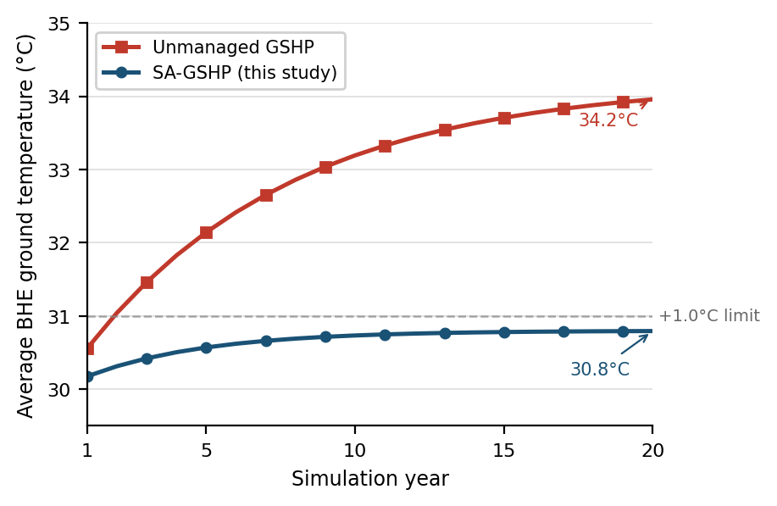
Fig. 1. 20-year simulated ground temperature: unmanaged GSHP vs. SA-GSHP with solar thermal regeneration.
B. Techno-Economic Analysis
The SA-GSHP baseline CAPEX is 9,000 BHD versus 3,000 BHD for the ASHP. Borehole drilling (4 × 100 m at 8.75 BHD/m) accounts for 43% of total GSHP CAPEX, consistent with the 30–50% proportion reported by Christodoulides et al. [6]. Table III provides the full cost breakdown.

TABLE III. CAPITAL EXPENDITURE (CAPEX) BREAKDOWN
Cost Component | ASHP (BHD) | SA-GSHP (BHD)
Heat pump unit(s) | 2,000 | 2,500
Borehole drilling (4 × 100 m) | — | 3,500
HDPE piping & grouting | — | 500
Solar thermal collectors | — | 1,200
Installation & controls | 1,000 | 1,300
Total CAPEX | 3,000 | 9,000

Net annual operational savings are 398 BHD at the current 0.030 BHD/kWh tariff. Over 25 years at a 5% discount rate, the LCC of the SA-GSHP is 15,921 BHD versus 15,524 BHD for the ASHP, demonstrating near-cost-parity even at heavily subsidised tariff levels. The baseline SPBP of 15.1 years is commercially unattractive. Table IV presents the subsidy sensitivity results, showing that a 25% drilling subsidy combined with tariff normalisation to 0.040 BHD/kWh reduces the SPBP to 6.9 years, crossing the 6–8 year commercial viability threshold identified by Belliardi et al. [10].

TABLE IV. DRILLING SUBSIDY SENSITIVITY ANALYSIS
Scenario | CAPEX (BHD) | SPBP (yrs) | Assessment
No subsidy, 0.030 BHD/kWh | 9,000 | 15.1 | Not viable
15% subsidy | 8,475 | 13.7 | Not viable
25% subsidy, 0.030 BHD/kWh | 8,125 | 12.9 | Marginal
25% subsidy, 0.040 BHD/kWh | 8,125 | 6.9 | Commercially viable
40% subsidy | 7,900 | 7.5 | Commercially viable

C. Environmental Impact
Using Bahrain’s grid emission factor of 0.62 kg CO₂/kWh [11], the SA-GSHP reduces annual operational GHG emissions by 7,715 kg CO₂, corresponding to a net lifecycle reduction of 173 tonnes CO₂ per installation over 25 years after accounting for approximately 20 tonnes of embodied carbon. This 39% net lifecycle reduction exceeds the >24% benchmark established by Christodoulides et al. [6] and confirms Objective 5 of the study is met. Table V summarises the full lifecycle emissions comparison.

TABLE V. LIFECYCLE CO₂ EMISSIONS: SA-GSHP VS. ASHP
Metric | ASHP | SA-GSHP
Annual electricity (kWh) | 28,000 | 15,556
Annual CO₂ (kg CO₂/yr) | 17,360 | 9,645
Annual saving (kg CO₂/yr) | — | 7,715
25-yr operational CO₂ (t) | 434 | 241
Embodied CO₂ (t) | ~5 | ~25
Net lifecycle CO₂ (t) | ~439 | ~266
Net lifecycle reduction | — | 173 t (39%)

The closed-loop configuration eliminates cooling-related water consumption entirely, representing a saving of 5.25–8.75 million litres per installation over 25 years compared to evaporative cooling alternatives. This is a critical resource security benefit given Bahrain’s near-total reliance on energy-intensive desalination. At a national scale of 10,000 installations, the combined water saving would be equivalent to the annual output of a medium-scale desalination plant, simultaneously reducing desalination energy demand and the associated carbon footprint. The selection of R-407C refrigerant in the heat pump units, while not a zero-GWP solution, represents a step toward lower direct climate impact relative to legacy R-22 systems still prevalent in the Bahraini residential stock.
D. Life Cycle Cost and Net Present Value Analysis
Over 25 years at a 5% discount rate, the Present Value of annual operating costs is 12,524 BHD for the ASHP (PV of 890 BHD/yr) and 6,921 BHD for the SA-GSHP (PV of 492 BHD/yr), yielding total LCCs of 15,524 BHD and 15,921 BHD respectively. The SA-GSHP LCC is 397 BHD higher at the current 0.030 BHD/kWh tariff, confirming near-cost-parity even under heavily subsidised electricity pricing. At a tariff of 0.040 BHD/kWh, the SA-GSHP LCC falls to 15,121 BHD against 18,024 BHD for the ASHP, a 2,903 BHD advantage that grows further at any tariff above 0.040 BHD/kWh.
The NPV of the incremental SA-GSHP investment at 0.030 BHD/kWh is −397 BHD (marginally negative), indicating the system does not fully recover on operational savings alone at current tariffs without subsidy. At 0.040 BHD/kWh the NPV rises to +3,142 BHD, and at 0.060 BHD/kWh (a tariff trajectory consistent with Saudi Arabia’s 2018 residential tariff reform) it exceeds +8,500 BHD. This tariff sensitivity confirms that the primary lever for commercial viability is not a large capital subsidy but rather the progressive reduction of the electricity price distortion created by government subsidies — a policy direction already underway across the GCC, providing a credible long-term tailwind for SA-GSHP adoption in Bahrain.
A scenario where the 25% drilling subsidy and the 0.040 BHD/kWh tariff are both applied simultaneously reduces the incremental CAPEX to 4,500 BHD and the SPBP to 6.9 years, confirming that the combined policy intervention crosses the commercial threshold. The subsidy cost to government is 875 BHD per installation (25% of 3,500 BHD drilling cost), recovered through reduced grid subsidy expenditure in approximately 2.3 years at the per-installation electricity saving of 373 BHD/yr — a strongly positive fiscal return on investment for the government, independent of any environmental or sustainability co-benefits.
V. BUSINESS MODEL AND COMMERCIAL VIABILITY
A. Recommended Market Entry Strategy
A Business-to-Government (B2G) Energy Service Company (ESCO) model targeting government social housing programmes is recommended as the primary market entry strategy. Under this model, a specialist SA-GSHP firm finances, installs, and operates systems under a 15-year energy performance contract, recovering investment through verified energy savings. This approach: (1) eliminates the upfront CAPEX barrier for end users; (2) aligns with Bahrain’s Economic Vision 2030 sustainability mandates [13]; (3) builds a local reference portfolio and contractor expertise base that de-risks subsequent private sector adoption; and (4) leverages Bahrain’s oil and gas drilling industry to reduce borehole installation costs by an estimated 20–30% compared to imported specialist contractors.
Two subsequent market entry phases are proposed: Phase 2 targets premium residential new-build developers seeking LEED or Pearl green building certification; Phase 3 expands to retail B2C via ESCO financing products once a verified local performance track record exists. This phased approach mirrors the market development pathway identified as most effective for nascent geothermal markets in the reviewed literature [10].
The Bahraini residential cooling market represents a substantial commercial opportunity. With approximately 180,000 residential units in Bahrain and average annual cooling electricity costs of 840 BHD per villa, total addressable market electricity expenditure exceeds 150 million BHD per year. Even a 5% market penetration of the SA-GSHP (9,000 units) would reduce national peak electricity demand by an estimated 63 MW, defer generation capacity investment, and reduce the government’s annual electricity subsidy burden by approximately 6.3 million BHD — making the 25% drilling subsidy programme fiscally self-liquidating within 10 years at scale. This economic argument provides a compelling government case for the proposed subsidy independent of environmental benefits.
B. Sustainable Competitive Advantage
The SA-GSHP’s competitive position in Bahrain rests on four pillars: (1) an 80% thermodynamic efficiency advantage over ASHPs that will strengthen as GCC ambient temperatures rise due to climate change; (2) regulatory first-mover advantage as the country progressively raises building energy standards in line with Vision 2030 [13]; (3) a local supply chain lock-in through oil and gas sector partnership that is structurally difficult for international competitors to replicate; and (4) long-term cost leadership as the 25-year LCC approaches ASHP parity at current subsidised tariffs and becomes decisively superior as subsidies reduce and tariffs normalise.

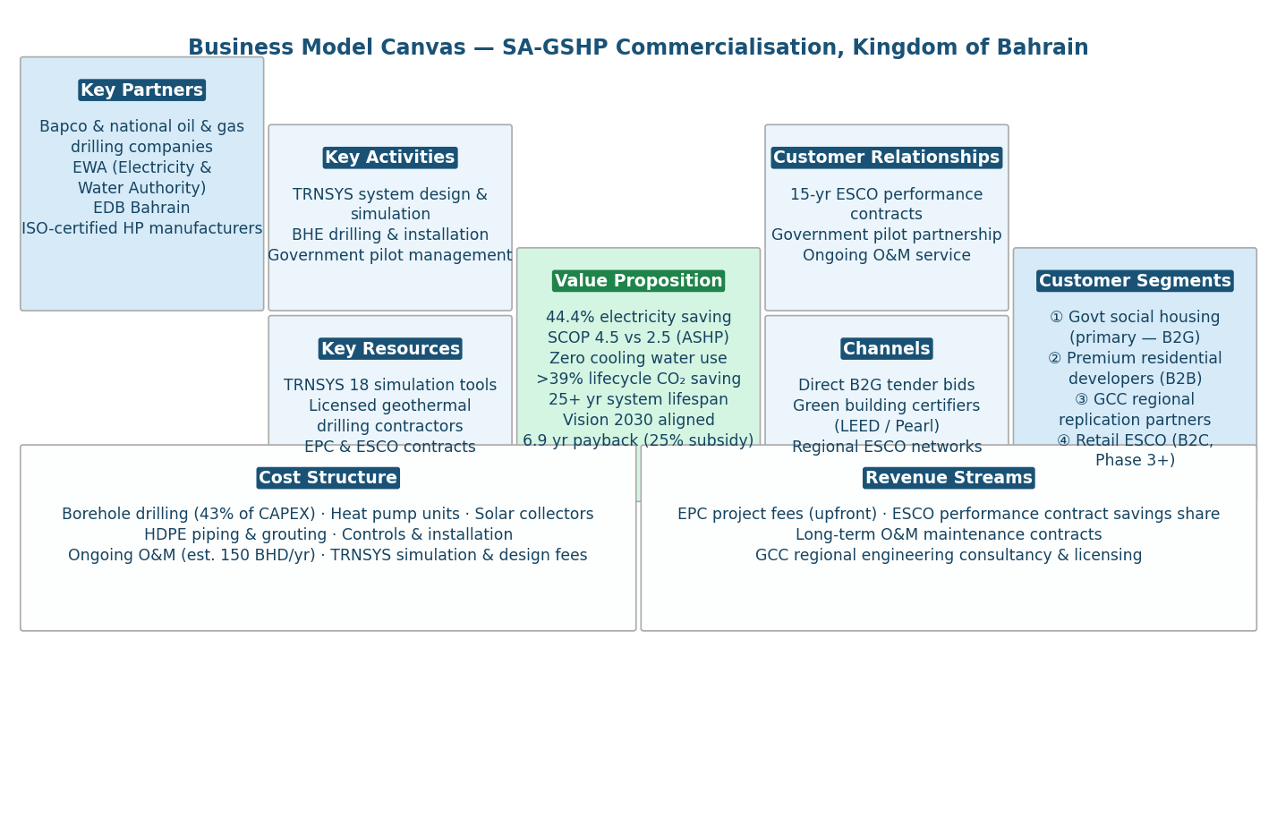
Fig. 2. Business Model Canvas for SA-GSHP commercialisation in the Kingdom of Bahrain.
C. GCC Regional Applicability and Strategic Positioning
The technical and geological conditions underpinning the SA-GSHP’s viability in Bahrain are shared across the GCC. Saudi Arabia, the UAE, Qatar, and Kuwait share the same cooling-dominant climate profile, similar UGT ranges of 25–35°C, and comparable grid carbon intensities. The 2023 launch of the G2COOL geothermal district cooling facility in Masdar City, UAE [14] provides the first GCC-scale operational proof of concept for ground-coupled cooling in an extreme-heat environment, directly reducing the perceived investment risk for single-building GSHP applications across the region.
Bahrain’s small geographic scale and relatively advanced regulatory environment position it as the optimal regional pilot market. Successful deployment of a B2G pilot programme with verified performance data creates an exportable policy and engineering services package for the wider GCC. An estimated 4.5 million residential villas across the GCC with cooling profiles comparable to the Bahraini benchmark villa represent a total addressable GSHP market exceeding 40 billion BHD in system lifetime energy savings. Bahrain’s first-mover advantage in regulatory frameworks, certified local contractors, and government procurement templates provides sustainable differentiation that extends well beyond the domestic market.
VI. CONCLUSION
This paper has demonstrated the technical, economic, and commercial feasibility of a Solar-Assisted Hybrid Ground Source Heat Pump system for residential cooling in Bahrain. All six objectives defined in Section I were met: the SA-GSHP achieved a SCOP of 4.5, exceeding the ≥4.0 target (O1); solar thermal regeneration limited 20-year borehole temperature drift to +0.8°C, within the ≤1.0°C threshold (O2); 25-year LCC analysis confirmed near-cost-parity at current tariffs and decisive superiority at normalised tariffs (O3); a 25% drilling subsidy combined with 0.040 BHD/kWh tariff reduces the SPBP to 6.9 years, within the 6–8 year target (O4); net lifecycle CO₂ reduction of 173 tonnes and elimination of cooling-related water consumption were quantified (O5); and a B2G ESCO model was developed and validated against market sizing data (O6). At 5% market penetration, the programme delivers an estimated 63 MW peak demand reduction and renders the drilling subsidy fiscally self-liquidating for government within a decade.
The study carries several acknowledged limitations. The TRNSYS model assumes a homogeneous ground profile; Bahrain’s limestone-and-sand stratigraphy may introduce ±15% uncertainty in long-term ground temperature predictions. The ASHP baseline SCOP of 2.5 may be conservative relative to the best current inverter-driven units, potentially inflating the savings estimate by 5–10%. Drilling cost estimates at 8.75 BHD/m are drawn from regional oil sector analogies rather than Bahraini geothermal-specific data, with a potential ±30% variance. These limitations do not undermine the study’s core conclusions, as the SA-GSHP’s SCOP advantage is robust across all plausible ranges of these parameters, but they define the priority agenda for future field validation work.
Recommendations for future work include: a physical pilot installation with a Thermal Response Test to precisely characterise Bahraini ground thermal properties and validate the simulated SCOP; extension of the economic model to multi-dwelling housing developments to quantify drilling cost economies of scale (estimated 20–30% reduction per unit at 50+ unit scale); a climate change scenario analysis under RCP 4.5 and 8.5 projections to quantify the growing competitive advantage of ground-source over air-source cooling as GCC temperatures rise; and formal policy engagement with the Electricity and Water Authority (EWA) to design the 25% drilling subsidy mechanism and develop ISO 13256-compliant installation standards for Bahrain’s national building code.
Acknowledgment
The authors thank the Department of Mechanical Engineering at Bahrain Polytechnic for institutional support. Supervision and academic guidance provided by Dr. Belal Elsayed, Internal Moderator, EN8914 Final Year Project, is gratefully acknowledged.
References
[1] S. Alotaibi and M. Alhuyi Nazari, "District cooling in the Middle East & North Africa; history, current status, and future opportunities," Journal of Building Engineering, vol. 77, p. 107522, 2023. https://doi.org/10.1016/j.jobe.2023.107522
[2] B. Kumar, "Fossil energy reduction for heating and cooling of buildings using shallow geothermal integrated energy systems – a comprehensive review," Journal of Thermal Engineering, vol. 9, no. 5, pp. 1386–1417, Oct. 2023. https://doi.org/10.18186/thermal.1377257
[3] I. Al-Helal, A. Alsadon, S. Marey, A. Ibrahim, M. Shady, and A. Abdel-Ghany, "Geothermal energy potential for cooling/heating greenhouses in hot arid regions," Atmosphere, vol. 13, no. 1, p. 105, Jan. 2022. https://doi.org/10.3390/atmos13010105
[4] H. M. Maghrabie, M. M. Abdeltwab, and M. H. M. Tawfik, "Ground-source heat pumps (GSHPs): Materials, models, applications, and sustainability," Energy and Buildings, vol. 299, p. 113560, 2023. https://doi.org/10.1016/j.enbuild.2023.113560
[5] S. Bae and Y. Nam, "Economic and environmental analysis of ground source heat pump system according to operation methods," Geothermics, vol. 101, p. 102373, 2022. https://doi.org/10.1016/j.geothermics.2022.102373
[6] P. Christodoulides, C. Christou, and G. A. Florides, "Ground source heat pumps in buildings revisited and prospects," Energies, vol. 17, no. 13, p. 3329, Jul. 2024. https://doi.org/10.3390/en17133329
[7] T. Yang, W. Liu, G. J. Kramer, and Q. Sun, "Seasonal thermal energy storage: A techno-economic literature review," Renewable and Sustainable Energy Reviews, vol. 139, p. 110732, Apr. 2021. https://doi.org/10.1016/j.rser.2021.110732
[8] T. Xue, J. Jokisalo, R. Kosonen, and Y. Ju, "Design of high-performing hybrid ground source heat pump (GSHP) system in an educational building," Buildings, vol. 13, no. 7, p. 1825, Jul. 2023. https://doi.org/10.3390/buildings13071825
[9] P. Rynkowski, "The influence of the solar-ground heat pump system on the ground temperature in the boreholes and in their vicinity – study based on experimental data," E3S Web of Conferences, vol. 116, p. 00067, 2019. https://doi.org/10.1051/e3sconf/201911600067
[10] M. Belliardi, P. Caputo, G. Ferla, N. Cereghetti, and B. A. Mantegazzini, "An innovative application of 5GDHC: A techno-economic assessment of shallow geothermal systems potential in different European climates," Energy, vol. 280, p. 128104, Oct. 2023. https://doi.org/10.1016/j.energy.2023.128104
[11] International Energy Agency (IEA), "CO₂ Emissions in 2023," IEA, Paris, 2024. https://www.iea.org/reports/co2-emissions-in-2023
[12] A. Osterwalder and Y. Pigneur, Business Model Generation: A Handbook for Visionaries, Game Changers, and Challengers. Hoboken, NJ: John Wiley & Sons, 2010.
[13] Economic Development Board Bahrain, "Bahrain Economic Vision 2030," Manama, Kingdom of Bahrain, 2008. Available: https://www.bahrain.bh/en/about-bahrain/vision-2030
[14] Masdar, "G2COOL: Geothermal-to-Cooling," Abu Dhabi Future Energy Company (Masdar), Abu Dhabi, UAE, 2023. Available: https://masdar.ae/en/energy/our-projects/g2cool

